

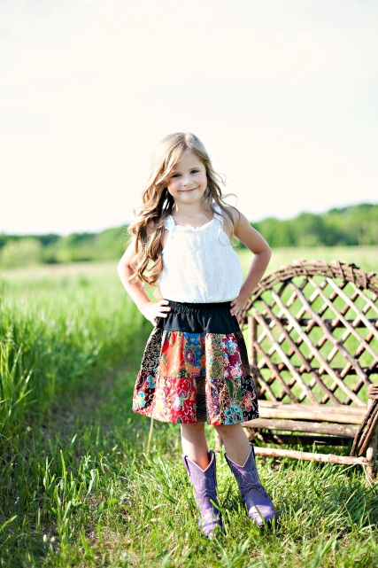


[Type a quote from the document or the summary of an interesting point. You can position the text box anywhere in the document. Use the Drawing Tools tab to change the formatting of the pull quote text box.]
[Type a quote from the document or the summary of an interesting point. You can position the text box anywhere in the document. Use the Drawing Tools tab to change the formatting of the pull quote text box.]
Silk Long Pajama Pants
$22.00
Lady Bug Child’s Purse
$19.08
Need shawls name
$45.00
Necklace Name
$45.00
Child’s 2 Tiered Skirt
$20.00-25.00
Carnelian Necklace
$30.00

